Ch03 handout. 1 wire & pwm

# Parts List

* Raspberry Pi - any model with GPIO headers
* Jumper wires
* Breadboard
* 10K Ω resistor
* 0 - 5 volt DC meter
* 1 or more DS18B20 one-wire temperature sensor

# Circuit diagram

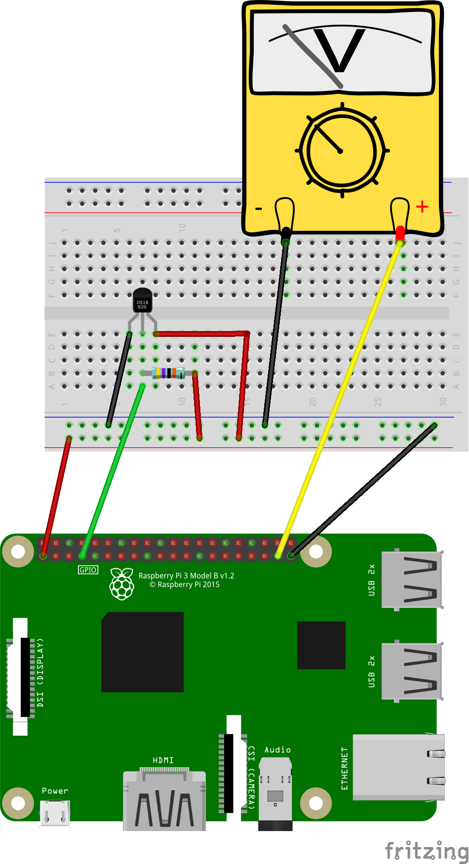

# Circuit description

* Connect Power and Ground
  + Connect GPIO pin 1 (3.3 vdc) to breadboard power rail
  + Connect GPIO pin 39 (ground) to breadboard ground rail
* Connect one or more DS18B20
  + Connect DS18B20 black wire to breadboard ground rail
  + Connect DS18B20 yellow wire to GPIO pin 7 (GPIO4 / 1-wire)
  + Connect DS18B20 red to breadboard power rail (3.3 vdc)
  + Connect 10k Ω resistor from DS18B20 yellow to breadboard power rail
* Connect meter
  + Connect Meter ground to breadboard ground
  + Connect Meter signal to GPIO pin 37 (GPIO 26)